

**A database is...**

**Name:**

**Real-life examples of databases:**

HOW might the following use a database?

Data electronically stored in servers

**TRUE or FALSE?** – delete the tick or cross the following:   ?

Police:

Recording down criminals and the data for salaries etc.

Mobile Phone:

They need to store temporary storage for files

Shop:

Databases can store large numbers of records about most things. (🗹)

* It’s quick and easy to find information in a database (🗹)
* It’s easy to add and delete data from a database (🗹)
* Databases can keep information organised and give you the power to use it how you like. (🗹)
* Data in databases is always secure and can’t be stolen (🗷)
* You’re allowed to collect data in a database about anything and anyone (🗹)
* You can hold data in an electronic database for however long you like (🗹)

Recording the price of products in different periods

Library:

Store each book’s information and their category

**EXTENSION**

Write a short report to explain HOW the police are using databases. Here are some links to help:

http://www.bbc.co.uk/newsbeat/10738138

http://news.bbc.co.uk/newsbeat/hi/technology/newsid_7699000/7699519.stm

http://news.bbc.co.uk/newsbeat/hi/the_p_word/newsid_8037000/8037899.stm

**Did you know…?** Microsoft Access can be used to create databases.

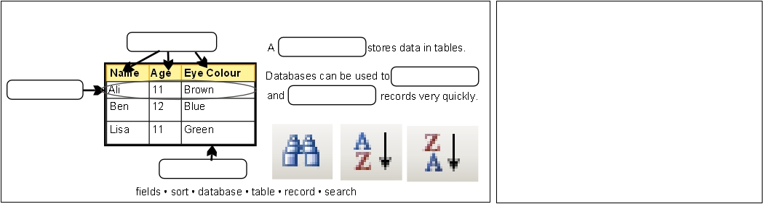**Complete the gaps!** Use the words at the BOTTOM to fill in the blanks **Rate yourself!** I can… (tick…)

cel

Field

 Define what a database is

 Give real-life examples of databases

store

 Explain advantages of using an electronic database

Record

record

 Explain a database table, field, record

Table

**Designing a database table:** Use this table to design a database table for collecting information about **wildlife**. Enter some example records.

|  |  |  |  |
| --- | --- | --- | --- |
| * Name of Animal | * Average Weight (kg) | * Life expectancy(years) | * Land, Sea/Air |
| * Human | * 60 | * 75 | * land |
| * Crocodile. | * 500 | * 80 | * water |
| * hippo | * 1500 | * 45 | * water |
| * dog | * 7.5 | * 11 | * land |
| * cat | * 4 | * 4 | * land |
| * blue whale | * 140000 | * 100 | * water |
| * bat | * 1 | * 38 | * air |
| * sparrow | * 0.03 | * 3 | * air |

|  |  |  |  |
| --- | --- | --- | --- |
|  |  |  |  |